Activity 7: Basic Algebra
One of the most useful and dynamic applications of algebra in physics is in the context of colliding objects. We can use “conservation of momentum” to predict what will happen after any two objects collide. A moving object’s momentum (confusingly abbreviated by the letter p) is simply defined to be it mass (m) times its velocity (V): p = mV.
The fun starts when two objects collide with each. (A very fun example would be a tanker truck and box car headed towards each other.) We usually call the two colliding objects A and B.
V_{A1}
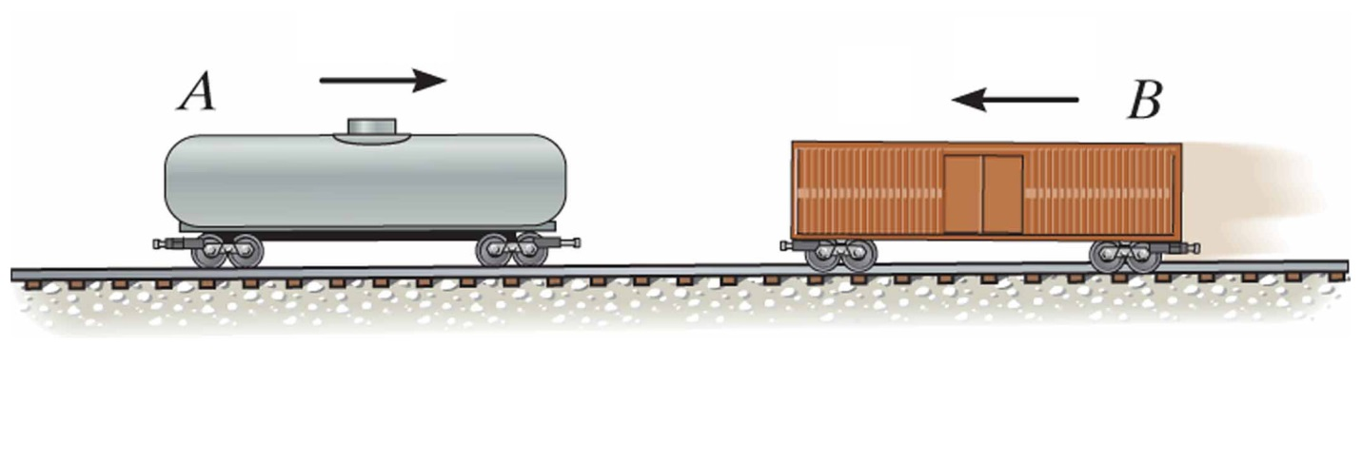
V_{B1}
If we call the velocities that A and B have the instant before they hit each other V_{A1} and V_{B1,} the two have momenta (the plural of momentum) p_{A}= m_{A} V_{A1} and p_{B} = m_{B} V_{B1}. During their collision, A hits B and B hits A back, so, as you will learn in your physics I class, any momentum gained by B must be lost by A (or vice versa). This keeps the total momentum of the two objects added together, m_{A} V_{A1} + m_{B} V_{B1}, from changing. (Note: Everything gets more complicated if the objects can bounce off each other at angles. We won’t do that here.) When a physical quantity cannot change, like the total momentum, a physicist says that quantity is conserved.
After the two objects bounce off of each other, we usually call the velocities, V_{A2} and V_{B2}, so the total momentum of the two after is m_{A} V_{A2} + m_{B} V_{B2.}
V_{A2}
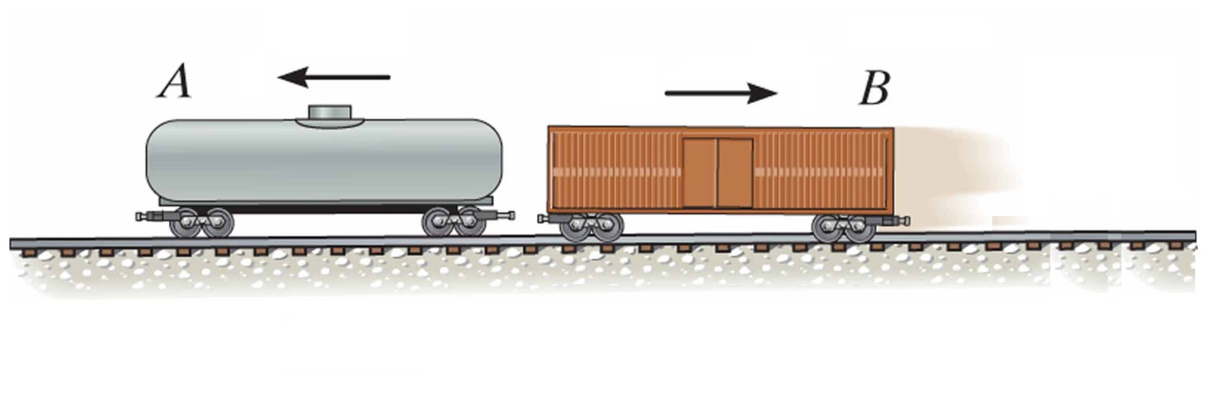
V_{B2}
The basic equation for conservation of momentum is m_{A} V_{A1} + m_{B} V_{B1} = m_{A} V_{A2} + m_{B} V_{B2.}
- Start off by assuming that we are interested in what B was doing before the collision.

- Take the conservation of momentum equation above and algebraically solve for the initial velocity of B, V_{B1}.

- Assume that the tanker-truck mass A is 4000 kg and box-car mass B is 2000 kg. If A is going 2 m/s before the collision and both A and B are going 1 m/s after the collision (this would mean that they stuck to each other), how fast was B going before the collision?

- Explain the meaning of the sign on your answer.

- Physicists end up doing so much algebra because they are interested in answering many different questions. Now, assume we’d like to know what A was doing after the collision.

- Take the conservation of momentum equation and algebraically solve for the final velocity of A, V_{A2}.

- Using the previous equation for V_{A2}, fill in the following table. Give your answers in terms of the velocity V. (No numbers are needed to do these calculations.)

m_{A} | m_{B} | V_{A1} | V_{B1} | V_{A2} | V_{B2}
m | m | V | 0 |  | V
2m | m | V | 0 |  | V
m | m | V | -V |  | V/2
m | 2m | V | 0 |  | Same as V_{A2}
m | 2m | V | -V |  | Same as V_{A2}

- A car is on a ferry boat in the middle of a large lake. Initially, both the car and the ferry are at rest. Bored, the driver of the car starts his car and drives (very carefully) to the left.

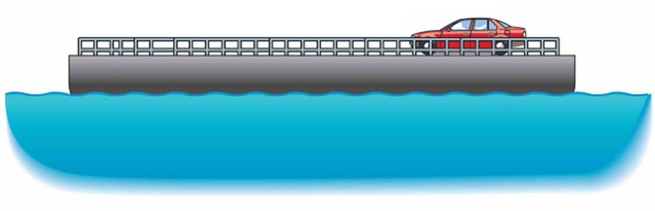

- If the speedometer of the car is reading V_{speed}, explain why conservation of momentum tells us that the car will actually be going slower than what the speedometer reads. (At least according to someone who’s looking at the car from the lakeshore.)

- In fact, the actual speed of the car will be V_{car} = V_{ferry} - V_{speed}. Substitute this expression as the final velocity of the car into the conservation of momentum equation and algebraically solve for the final velocity of the ferry, V_{ferry}. (Remember that any object at rest has zero velocity.)

- Assuming the ferry has a mass that is 10 times larger than the car and the car is driving with a speed of 4 m/s, find the speed of the ferry and the actual speed of the car. Do your answers make sense?

