Activity 19a: Exponential Growth and Decay

1. Exponential growth occurs frequently in financial problems, due to a quantity of invested money acquiring interest, which in turn is reinvested and generates more interest. Now, suppose you invest $5,000 in a retirement account that has a growth rate of 8% per year. This means that in the period of one year, the initial investment has grown to 108% (1.08) of what it originally was.

a) Let's try to find the equation describing this growth. We know it is exponential, so can be described by the equation $M\left(t\right)=M_{0} C^{t}$, where M is your money after t years, and $M_{0}$ and C are unknown constants. Now, how much money is in your account after 0 years (ie, initially)? How much after 1 year?

b) Use what you wrote down in part a to solve for $M_{0}$ and C. Show your work.

c) How much money will you have in your account after 6 months? How much after 20 years? After 40?

2. Newton's law of cooling says (among other things) that the temperature of an object left in a room decays exponentially to the temperature of the room. For example, suppose we leave a hot cup of tea in a room. If the temperature of the room is $T_{R}$, and the temperature of the tea when we first leave it there is $T_{0}$, then the temperature of the cup of tea varies with time as $T\left(t\right)= T_{R}+e^{-\frac{t}{t_{0}}} (T_{0}-T_{R})$.

a) Evaluate $T(t)$ at t = 0 and at very large t ($t→∞$). Explain why your answers agree with what you would have guessed based on physical intuition.

b) What are the units of $t_{0}$? In what way does the cooling process change if we increase or decrease the value of $t_{0}$?

c) If your cup of tea is at 90ºC when you leave it on the table, and the temperature of the room you leave it in is 25ºC, what's the temperature of your tea 15 minutes later if $t_{0}$ = 40 minutes? Show your work below.

3. People often confuse exponential and quadratic growth, since the graphs of these functions look similar. For example:
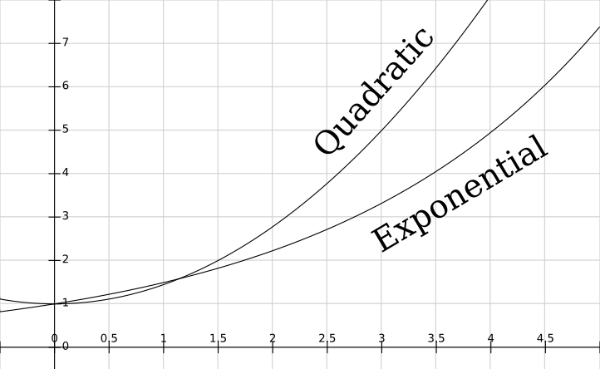
However, these functions are actually completely different in the long run.
a) Look at the functions $f(n)=2^{n}$ and $g(n) = n^{2}$. Write out the values of each of these functions for some small values of n, and find the ratio between the two, $\frac{f(n)}{g(n)}$. Notice how the exponential function quickly becomes much larger than the quadratic.
$$n$$ | 1 | 2 | 3 | 5 | 8 | 12
$$f(n)$$
$$g(n)$$
$$\frac{f(n)}{g(n)}$$

b) A famous story tells of a man who, after doing his king a great favor, is offered as a reward anything he wants. The man, being decently math-savvy, asks simply for a chessboard and a single grain of rice. Placing the grain of rice on the first square of the board he adds, “But tomorrow you must give me two grains of rice for the second square, the day after four grains for the third square, and so forth (doubling every day) until the board is filled up.” The king, never having taken a precalc class, scoffs at this, saying that such a trifling request is practically beneath him.
i) Given that our chess board has 64 squares, how many grains of rice would the man receive on the last square? If the Earth's current population is about 7 billion people, how many grains of rice is this per person?

ii) 1 pound of rice is roughly 30,000 grains. With the reward given on the 64th day, how many pounds of rice would each person on Earth be able to receive? How many tons is this? Do you think the king would have been able to grant this “trifling request”?

c) Now figure out how many grains of rice the man would have received on the 64th day if he had instead asked for a quadratic increase in payment (i.e. one grain on the first day, four grains on the second, nine grains on the third, etc.). How many pounds of rice is this total?

